#### PROJECT REPORT TEMPLATE

#### INTRODUCTION

* 1. OVERVIEW

The Title of the project allotted to our group is BUILD AN EMPLOYEE TRAVEL APPROVAL APPLICATION FOR CORPORATE. This project is aimed at creating a web-based application that streamlines the process of requesting and approving employee travel requests, provide necessary details such as the reason for travel, destination, duration, and estimated expenses

* 1. PURPOSE

Build an employee travel approval application for corporate is will provide a comprehensive solution for managing employee travel requests and expenses, improving the efficiency and accuracy of the process, and ultimately saving time and money for the organization.

Build an employee travel approval application for corporate is to create a more efficient, transparent, and cost-effective way to manage employee travel requests within an organization.

#### EMPATHY MAP :

#### 

**BRIAN STORMING MAP**

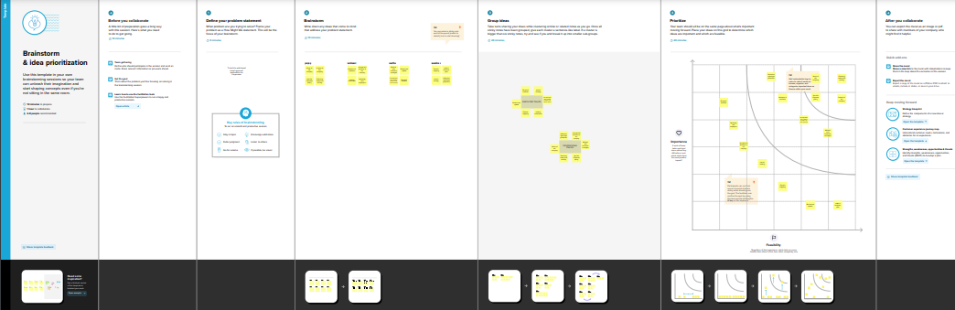

**Milestone 1- Create Salesforce Org:**

ACTIVITY 1

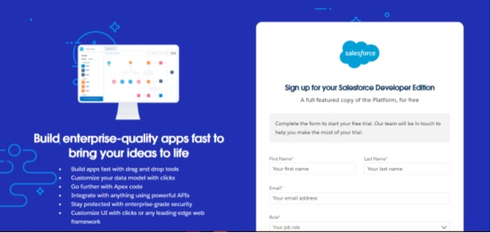

ACTIVITY 2

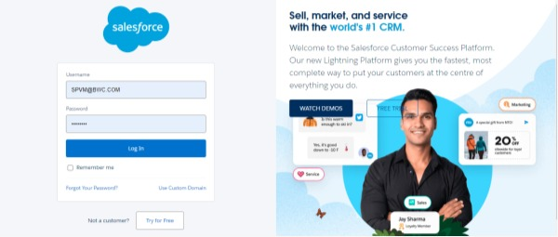

**Milestone 2 Creating the Application:**

ACTIVITY 1

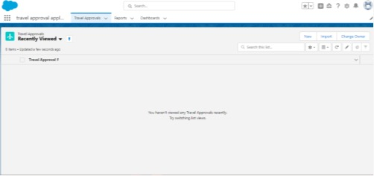

**Milestone 3 -What is an object?:**

ACTIVITY 1

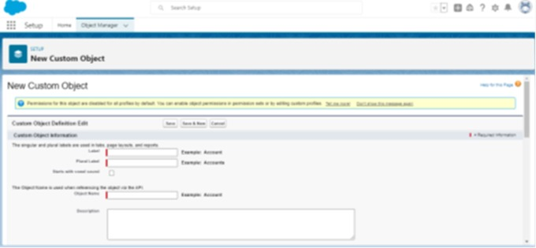

ACTIVITY 2

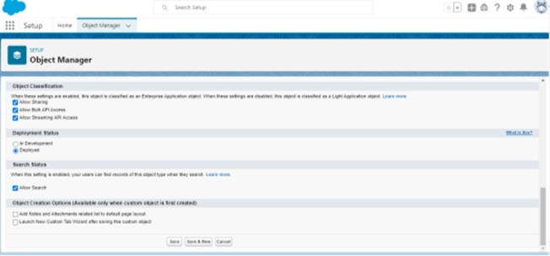

**Milestone 4-What is a Tab?**

ACTIVITY 1

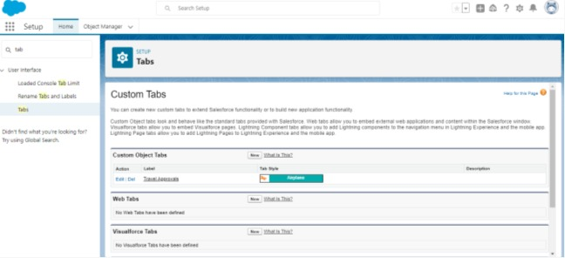

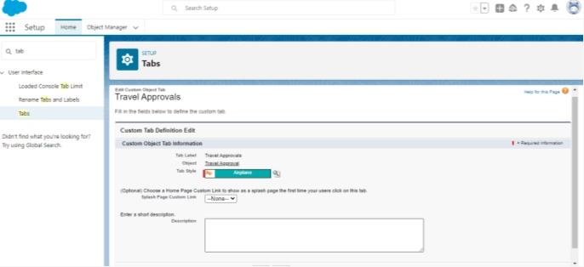

**Milestone 5 Create- Fields& Relationships:**

ACTIVITY 1,2,3:

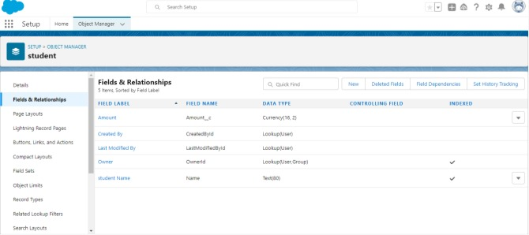

**Milestone 6-Import Departments :**

ACTIVITY 1

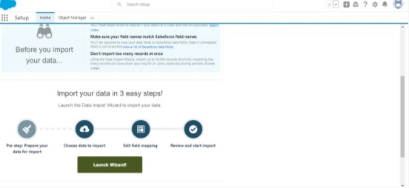

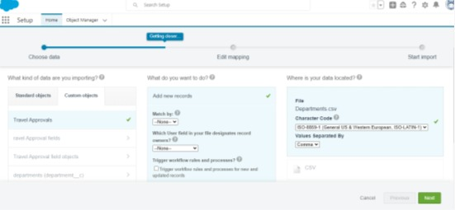

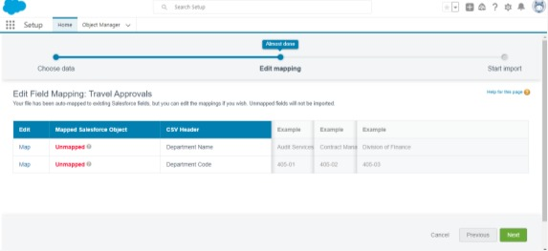

**Milestone 7-Customize User Interface**

ACTIVITY 1

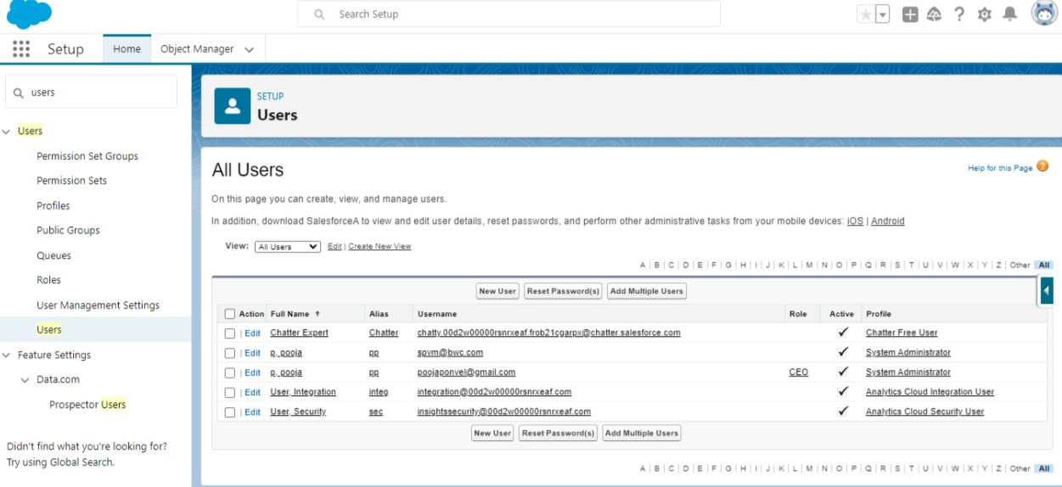

**Milestone 8- Use customization :**

ACTIVITY 1

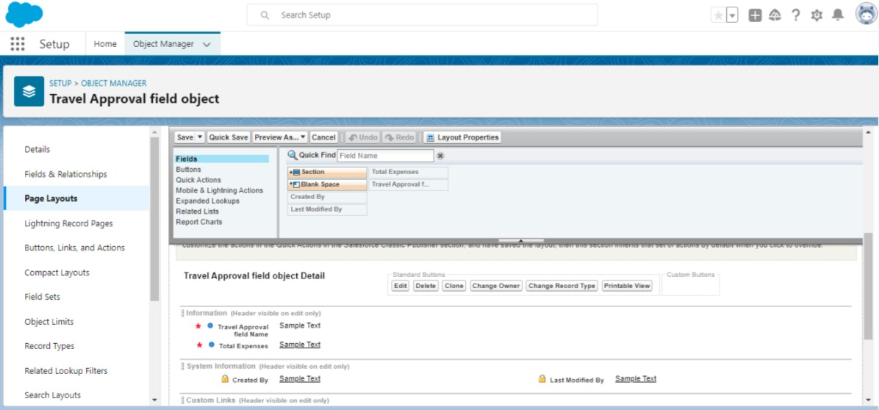

**Milestone 9-Add Business Logic to Travel App:**

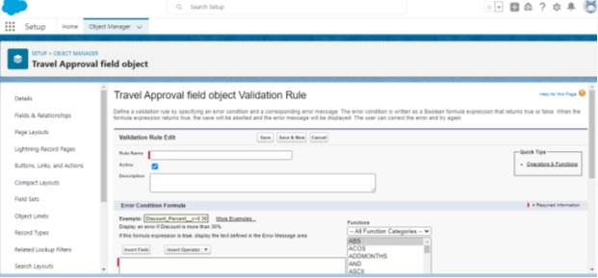

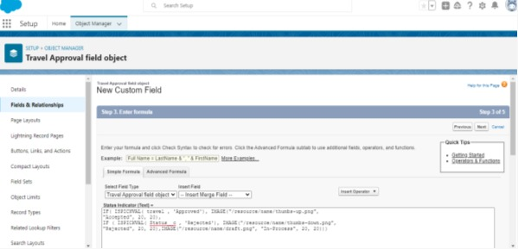

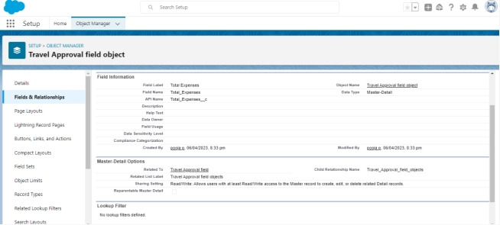

**Milestone 10-What are Reports?**

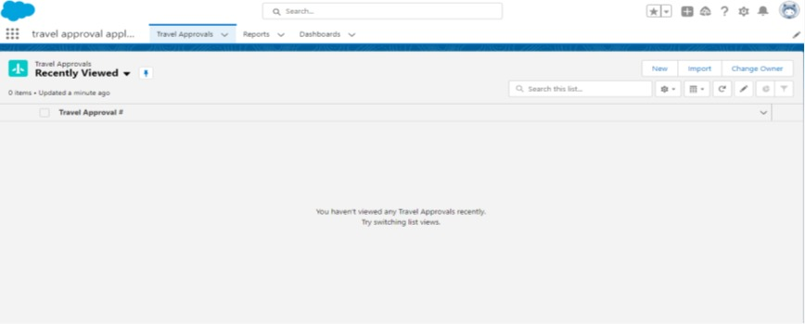

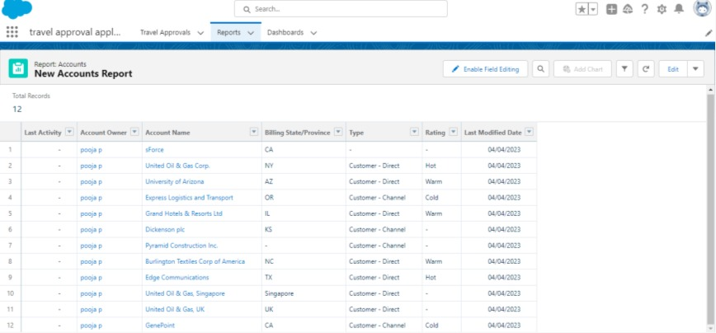

**Milestone 11- Dashboards:**

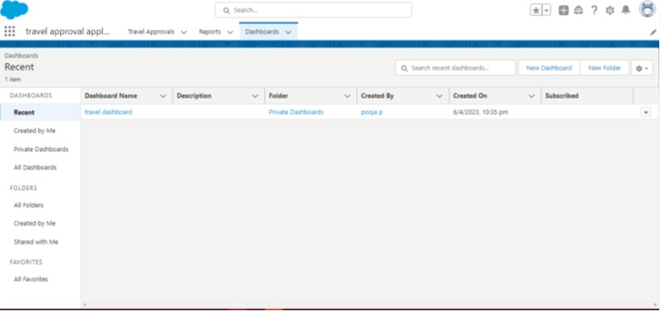

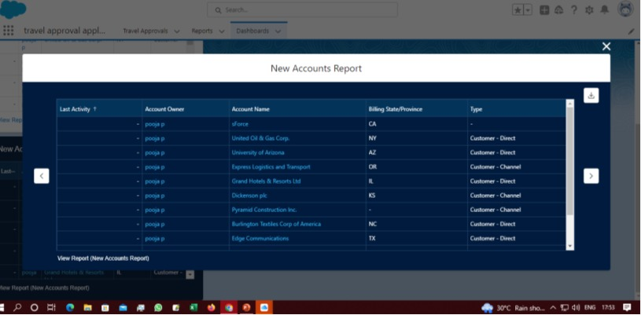

**3.RESULT**

3.1 BENEFITS

Benefits for the company

Reduce spikes in travel spend and gain control

Reduce friction and frustration over expenses and reimbursements

Reduce total costs on business travel and optimize your company's budget

Increase fairness and foster a positive company culture

BUSINESS TRAVEL BENEFITS BOTH EMPLOYEE AND EMPLOYERS IN SOME WAYS:

* Cost savings benefits of corporate travel
* Corporate travel time saving
* 24/7 business travel support
* Analytics for corporate travel
* Technology as a benefit of corporate travel

1. TRAILHEAD PROFILE PUBLIC *URL*

TEAM LEADER : Pooja P

TEAM MEMBER 1 : Monisha S

TEAM MEMBER 2 : Swetha R <https://trailblazer.me/id/ph-tr>

TEAM MEMBER 3 : Vaishnavi M <https://trailblazer.me/id/ph-tr>

1. ADVANTAGES AND DISADVANTAGES

ADVANTAGES:

**Automation:** The application can automate the travel approval process, reducing the workload of managers and HR teams.

**Transparency:** The database can provide transparency to the travel approval process, making it easier to track approvals and rejections.

**Centralized Data:** The database can store all employee travel requests, making it easy to review and analyze employee travel data.

**Improved Efficiency:** The application can reduce the turnaround time for travel approvals, ensuring that employees can make their travel plans without unnecessary delays.

**Better Budget Management:** The application can track travel expenses and provide real-time data to managers, helping them to manage travel budgets more efficiently.

DISADVANTAGES:

**Implementation Cost:** Building an employee travel approval application can be expensive and time-consuming, especially if it requires custom development.

**Maintenance:** The application will need ongoing maintenance and support to ensure that it continues to function as intended.

**Data Security:** The database will contain sensitive employee data, which requires proper security measures to be in place to protect against unauthorized access and breaches.

**Training:** Employees and managers will need to be trained on how to use the new system, which can require additional time and resources

6.CONCLUSION

In conclusion, Build an employee travel approval application for a corporate can greatly streamline and automate the travel approval process for organizations. The application can provide an efficient way for employees to submit their travel requests and for managers to review and approve them. The use of technology can reduce the time and effort involved in the approval process and improve the overall transparency and communication within the organization. Additionally, by digitizing the process, it can help reduce paper waste and promote sustainability. Overall, implementing Build an employee travel approval application corporate can benefit both the employee and the organization as a whole.

7.FUTURE SCOPE

It is vast and exciting. As technology continues to evolve enhance and improve the application.

One potential area for development is incorporating artificial intelligence (AI) and machine learning (ML) algorithms to help optimize the travel approval process. This could include using predictive analytics to identify potential issues or bottlenecks in the process, or utilizing natural language processing (NLP) to help managers quickly review and approve travel request.

Another potential area for development is integrating the application with other tools and platforms commonly used in organizations, such as expense management software or project management tools. This could help create a more seamless and integrated experience for employees and managers.

In, addition, there is potential to expand the application beyond just travel approval and into other areas of HR management, such as performance evaluations or leave requests. This could help create a more comprehensive and unified HR management system for organizations.

Overall, the future scope of the Build an employee travel approval application for corporate is promising, and there are many opportunities for innovation and improvement in the years to come.